**Topics: Descriptive Statistics and Probability**

1. Look at the data given below. Plot the data, find the outliers and find out $μ, σ, σ^{2}$

|  |  |
| --- | --- |
| **Name of company** | **Measure X** |
| Allied Signal | 24.23% |
| Bankers Trust | 25.53% |
| General Mills | 25.41% |
| ITT Industries | 24.14% |
| J.P.Morgan & Co. | 29.62% |
| Lehman Brothers | 28.25% |
| Marriott | 25.81% |
| MCI | 24.39% |
| Merrill Lynch | 40.26% |
| Microsoft | 32.95% |
| Morgan Stanley | 91.36% |
| Sun Microsystems | 25.99% |
| Travelers | 39.42% |
| US Airways | 26.71% |
| Warner-Lambert | 35.00% |

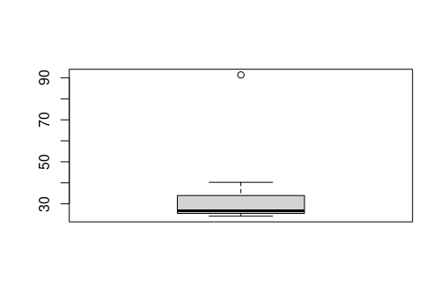

BOXPLOT

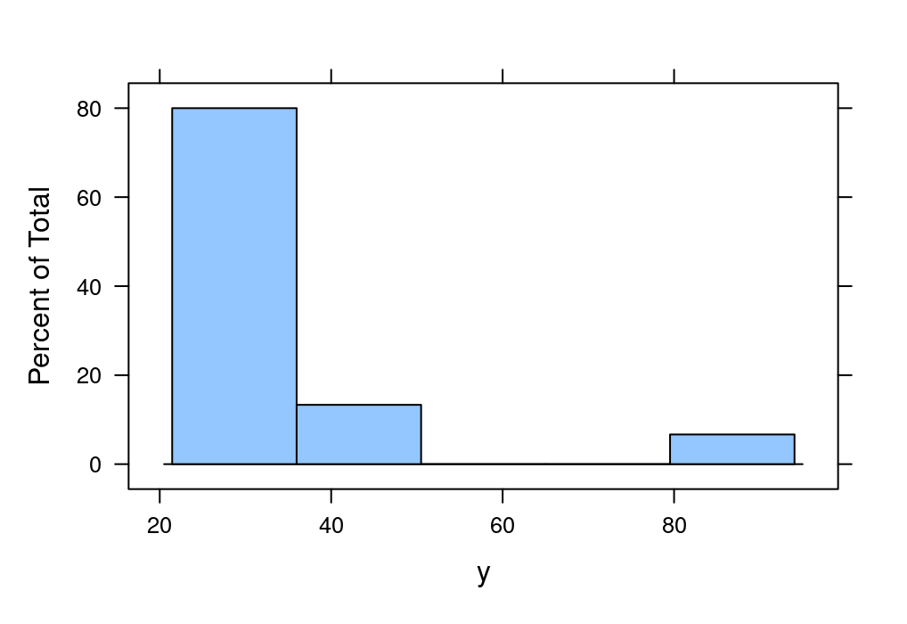

HISTOGRAM

OUTLIERS = 91.36%

MEAN = 33.27133

VARIANCE = 287.1466

STANDARD DEVIATION = 16.9454



Answer the following three questions based on the box-plot above.

1. What is inter-quartile range of this dataset? (please approximate the numbers) In one line, explain what this value implies.

IQR = Q3-Q1

= 12-5

= 7

1. What can we say about the skewness of this dataset?

- The dataset is Right-skewed as the data is more spreaded towards the right side of the graph and there is a presence of an outlier in the extreme right side of the boxplot.

1. If it was found that the data point with the value 25 is actually 2.5, how would the new box-plot be affected?

* The outlier that is the data point with the value 25 if, is 2.5 then the skewness would increase as the whisker length would increase to accommodate the data point.



Answer the following three questions based on the histogram above.

1. Where would the mode of this dataset lie?

-The mode would lie between the interval 5-10 value of ‘Y’ (approx. 7)

1. Comment on the skewness of the dataset. ￼

-The histogram is right-skewed as the data is spreading towards the right side of the graph.

1. Suppose that the above histogram and the box-plot in question 2 are plotted for the same dataset. Explain how these graphs complement each other in providing information about any dataset.

- Both the graphs would provide the presence of outliers

- Both the graphs will give the approx value of mean, median and mode.

- Both the graphs will give the info about the skewness of the data.

1. AT&T was running commercials in 1990 aimed at luring back customers who had switched to one of the other long-distance phone service providers. One such commercial shows a businessman trying to reach Phoenix and mistakenly getting Fiji, where a half-naked native on a beach responds incomprehensibly in Polynesian. When asked about this advertisement, AT&T admitted that the portrayed incident did not actually take place but added that this was an enactment of something that “could happen.” Suppose that one in 200 long-distance telephone calls is misdirected. What is the probability that at least one in five attempted telephone calls reaches the wrong number? (Assume independence of attempts.)

* The probability that a single call is misdirected is given as 1/200
* The probability that at least 1 out of 5 calls misdirected

X = number of misdirected calls out of 5 attempts

n = 5 (number of attempts)

p = 1/200 (probability of misdirect on a single call)

X follows a binomial distribution with parameters n and p

We want to find P(X ≥ 1)

By binomial probability, this is calculated as:

P(X ≥ 1) = 1 - P(X = 0)

P(X = 0) = (nC0) * p^0 * (1-p)^n

= (1) * (199/200)^5

Therefore, P(X ≥ 1) = 1 - (199/200)^5

= 0.025

1. Returns on a certain business venture, to the nearest $1,000, are known to follow the following probability distribution

|  |  |
| --- | --- |
| x | P(x) |
| -2,000 | 0.1 |
| -1,000 | 0.1 |
| 0 | 0.2 |
| 1000 | 0.2 |
| 2000 | 0.3 |
| 3000 | 0.1 |

1. What is the most likely monetary outcome of the business venture?

Expected value = (-2000 x 0.1) + (-1000 x 0.1) + (0 x 0.2) + (1000 x 0.2) + (2000 x 0.3) + (3000 x 0.1)

= -200 – 100 + 0 + 200 + 600 + 300

= 800

1. Is the venture likely to be successful? Explain

Based on the expected value, the venture is likely to be successful.

1. What is the long-term average earning of business ventures of this kind? Explain

The long-term average earning of business venture is the expected value or mean that is, 800.

1. What is the good measure of the risk involved in a venture of this kind? Compute this measure

The standard deviation calculated using the above data is equal to 964.365. The higher the standard deviation, higher is the risk associated with the venture.